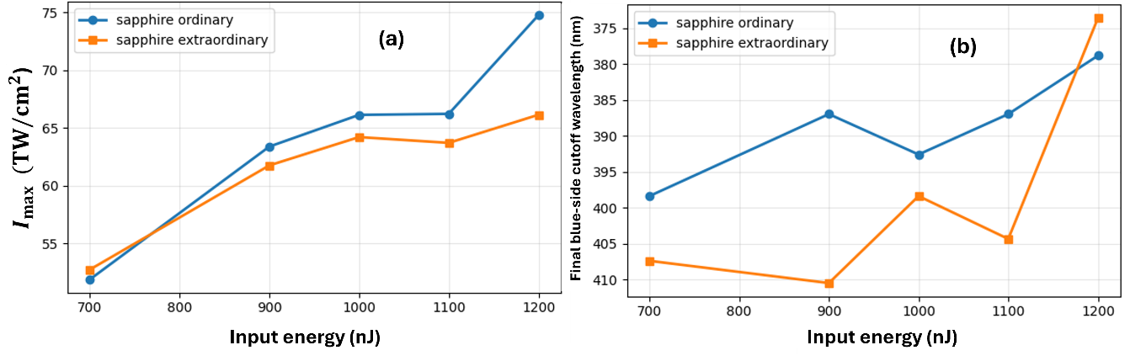
Figure 5. Polarization-dependent sapphire vortex propagation. Comparison of ordinary and extraordinary sapphire simulations for focused m=1 vortex pulses. (a) Maximum intensity as a function of input energy. The ordinary case generally produces higher peak intensities at intermediate and high energies. (b) Final-output blue-side cutoff wavelength as a function of input energy. Both polarizations exhibit substantial spectral broadening, with the extraordinary case showing the shortest cutoff at 1200 nJ. Since only the linear refractive index was varied between the two sapphire cases, the observed differences represent a first-order estimate of polarization-dependent propagation rather than a full tensorial anisotropic response.

